Setting up Atomic OAuth for Free Agent

1. Login to/set up a Free Agent dev account at <https://dev.freeagent.com/> (this is a separate account to your ordinary FA account
2. Find the OAuth identifier and secret

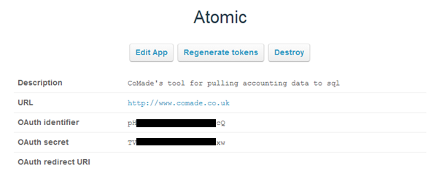

1. Go to google OAuth playground fill in the details from above under the cog/settings button

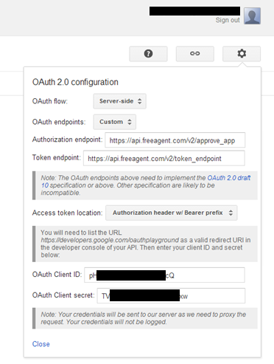

1. On the left click Select & Authorize APIs, put some gibberish into the select scope box (google requires this but FA does not). Click Authorize APIs

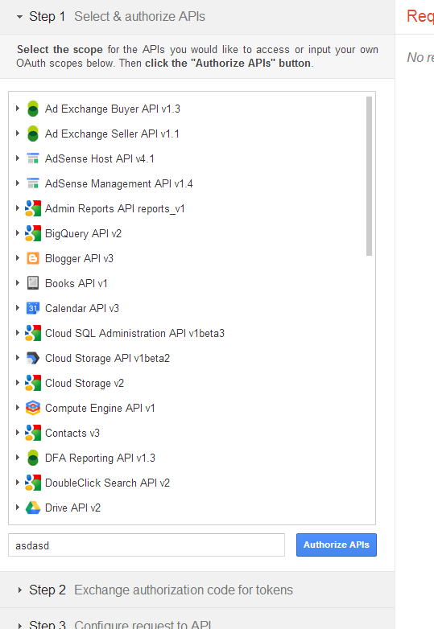

1. You should be taken to the Free Agent website, log in with your normal username and password, then approve the App.
2. You will be taken back to the playground website. Click Exchange authorization code for tokens. You will now have all the information you need.
3. In Atomic App add the following information to the App Config

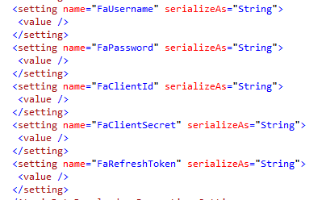

FaUsername = normal username

FaPassword = normal password

FaClientId = OAuth Identifier taken from the FA Dev website

FaClientSecret = OAuth Secret taken from the FA Dev website

FaRefreshToken = the refresh token from the google OAuth playground website

**NOTE**: If you are using a sandboxed FreeAgent implementation for developers then the url will be different to the aforementioned one. (Included in code and commented out).

END